Agile Testing Requirements

# Counting the # of As

## Requirement(s)

* A limit of a 1,000 character string.

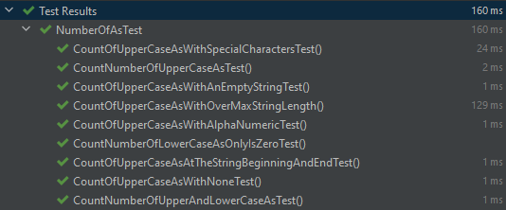

I also used Javadoc and ran the unit tests with code coverage:

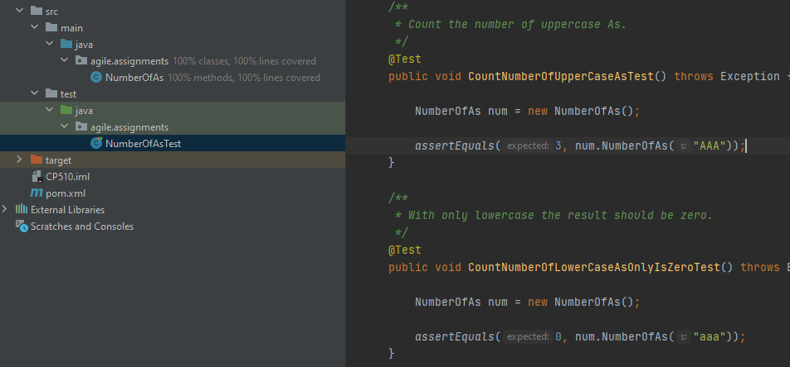

# Celsius to Fahrenheit

## Requirement(s)

* Input should be able to go to four decimal places.
* Positive and negative 1 billion.
* JS code should not be executed if submitted as input.

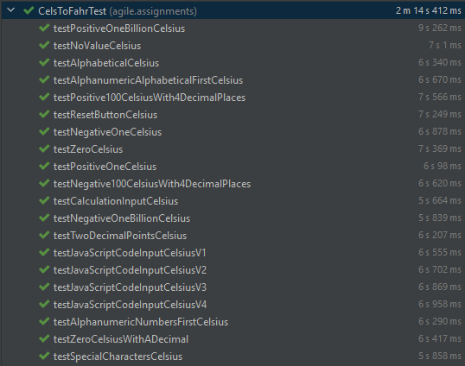

# Code and Documentation Location

<https://github.com/tbro28/agiletest>

# Video Demonstration with Explanation

* For best experience:
  + Make sure that the settings is set to 1080p
  + Watch at 1.25x speed
* <https://youtu.be/MM1OtgCk2oo>